**15-463 Computational Photography (Fall 2023)**

**Assignment 6**

Haejoon Lee

**1. Implementing structured-light triangulation**

**[Per-frame shadow edge estimation & Per-pixel shadow time estimation]**

66th frame

106th frame

**[Intrinsic and extrinsic calibration]**

Green: horizontal, Red: vertical

There were some errors on 3D points projection, especially on the vertical plane. We expect that it’s because of calibration errors, which could be resolved through more accurate calibration using the dual-space geometry procedure in the original paper.

**[Reconstruction]**

To improve our reconstruction, we set the boundary of ROI in our images only containing frog, filtered out points based on the Z-coordinate to slice out only frog.

**2. Building your own 3D scanner (100 points)**

**[Fork crane]**

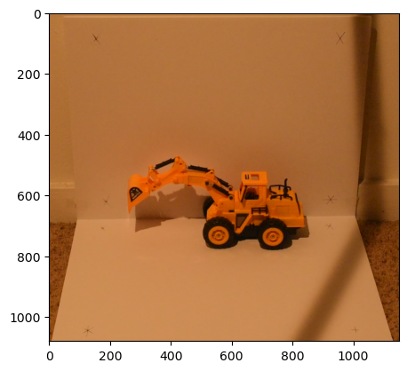

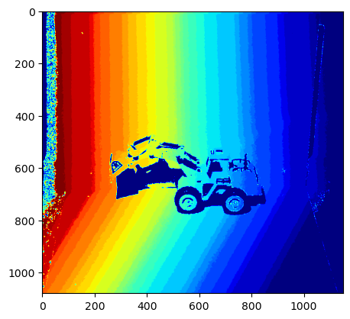

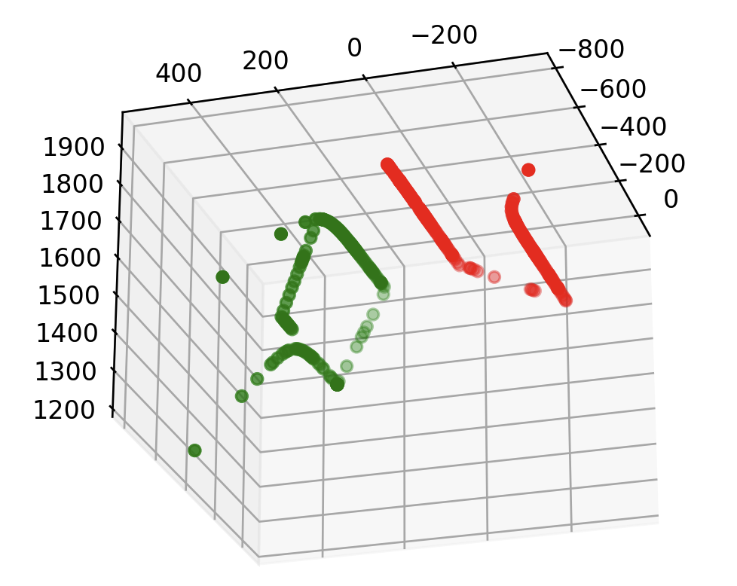

**[Pill packer bottle]**

To reduce the noise and improve the contrast of shadow’s edge, we applied bilateral filtering on the images. From the both objects, per-frame shadow edge, per-pixel shadow time estimation, and 3D points on shadow line were successfully computed with some errors. When the objects were 3D reconstructed, the results clearly showed that the object’s points are lied on the estimated 3D shadow plan, but also with its background. The first reason we expect is the Penumbra of shadow because of non-point light source, which led to the blurred and thick shadow.

The second reason could be the relatively small size of object in camera-projector distance scale. Because of that, shadow wasn’t bended much, which might led to estimate the background and object in the same depth.

**4 Bonus: Implement direct-indirect separation (100 points)**

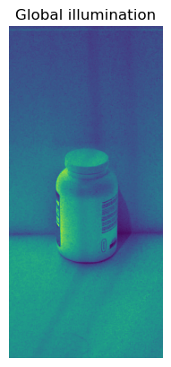Instead of radiometric calibration with exposure stack, we simply applied sRGB linearization and performed direct-global separation. As a result, it produced quite satisfying results. We can see the specular reflection in direct component, otherwise subsurface scattering in global components.